

**ASSIGNMENT#3**

**GROUP MEMBERS:**

RUTABA HAYAT FA23-BSE-220

ASNA AQEEL SP24-BSE-016

MUHIBBA FATIMA SP24-BSE-138

**Home Page**

On running the code, the main page will appear, which contains the two buttons, Create an Account and Login, and a toolbar with three icons, Home Page, Feedback, and Logout icons.

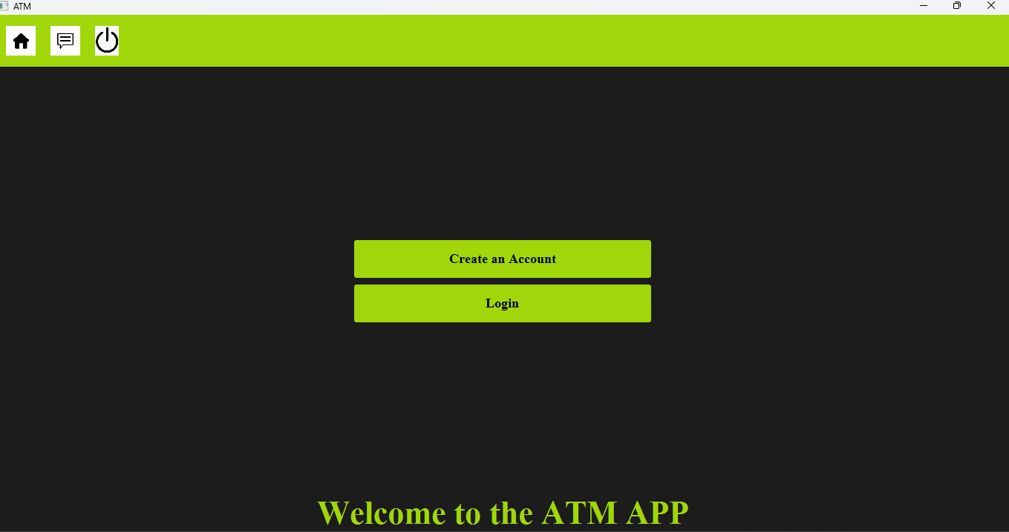

On clicking the Logout button, we will direct towards the main menu, which has the two buttons Create Account and Login button.

Feedback Button:

On clicking the Feedback icon on the toolbar, a new window will appear with the text area where we can enter the feedback about our application and submit the feedback. It also has back button which will direct us to main menu

**Account Creation**

when we click the Create an Account button, a new screen will be shown. That screen contains labels for username and password, and initial balance, and then a combo box for account type. These have two buttons, Create and Back. On clicking the Create button, an account will be created and stored in the file. On clicking the Back button, it will move towards the main menu.

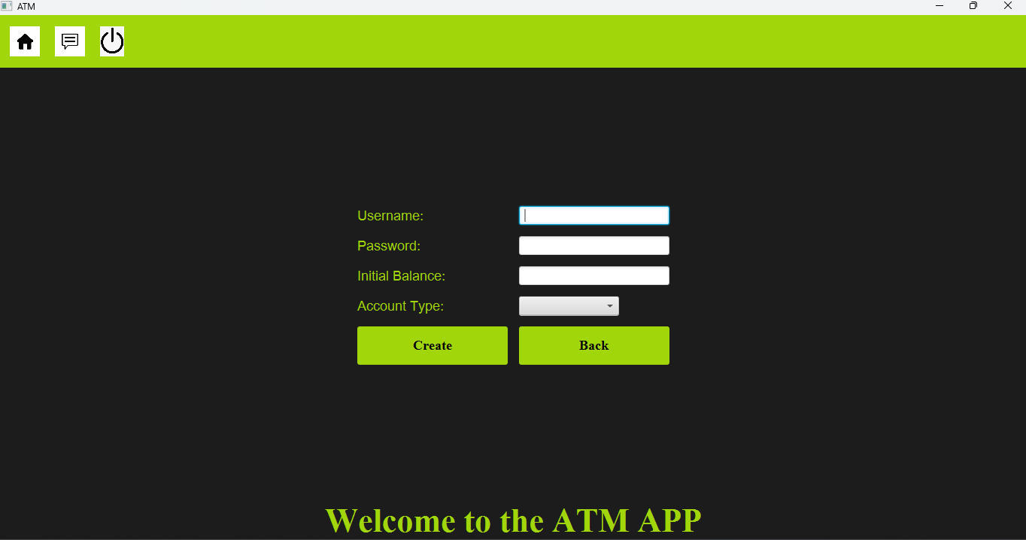

**Login page**

When we click on the login button, a new screen will be shown with the two text fields. One is for username and the other one is for password. After entering the password and username that we stored in the file by creating an account, we will enter the login button. When we enter the login button, a new screen will be shown.

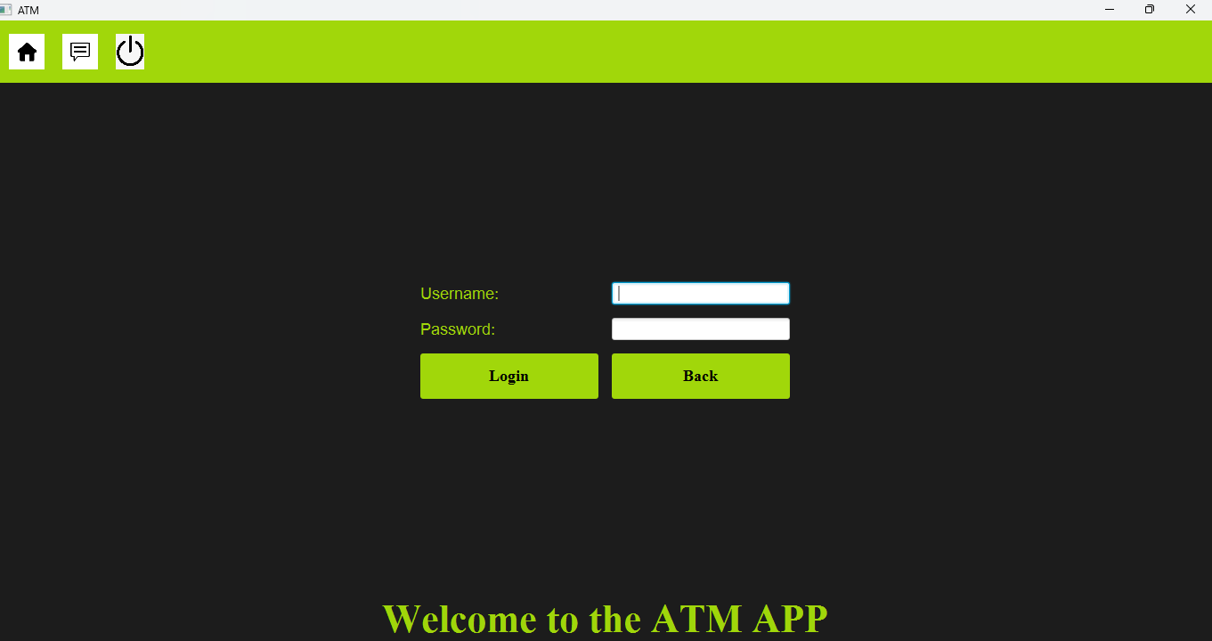

**Main Menu**

This window has 7 buttons, Withdrawal, Deposit, Balance inquiry, Transfer Funds, Delete Button, Change Password Button, and Logout Button. On clicking the Withdrawal button, a dialog box will appear on which we can enter the amount which we want to withdraw, and then the message label will be updated with the new amount.

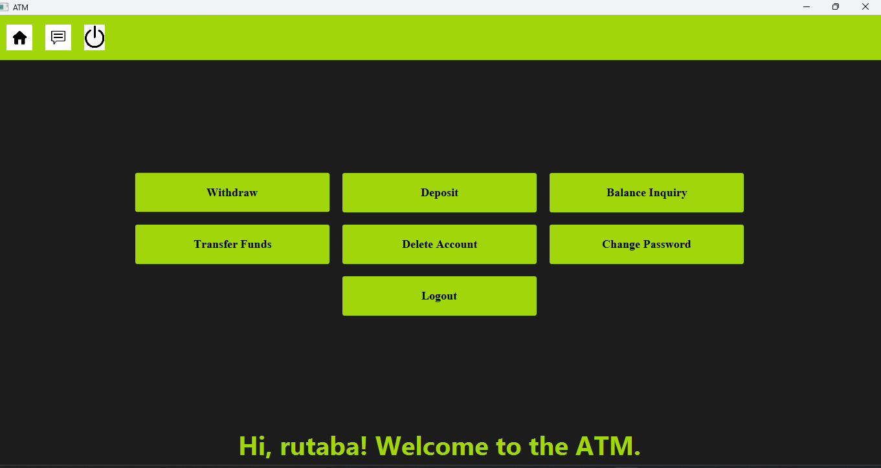

**Withdraw**

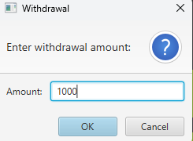

**Deposit**

On clicking the deposit button, a dialog box will appear on which we can enter the amount which we want to deposit, and then the message level will be updated again.

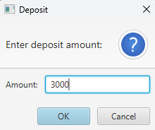

**Balance Inquiry**

On clicking the Balance in Query button, it will show the balance which we have in our account.

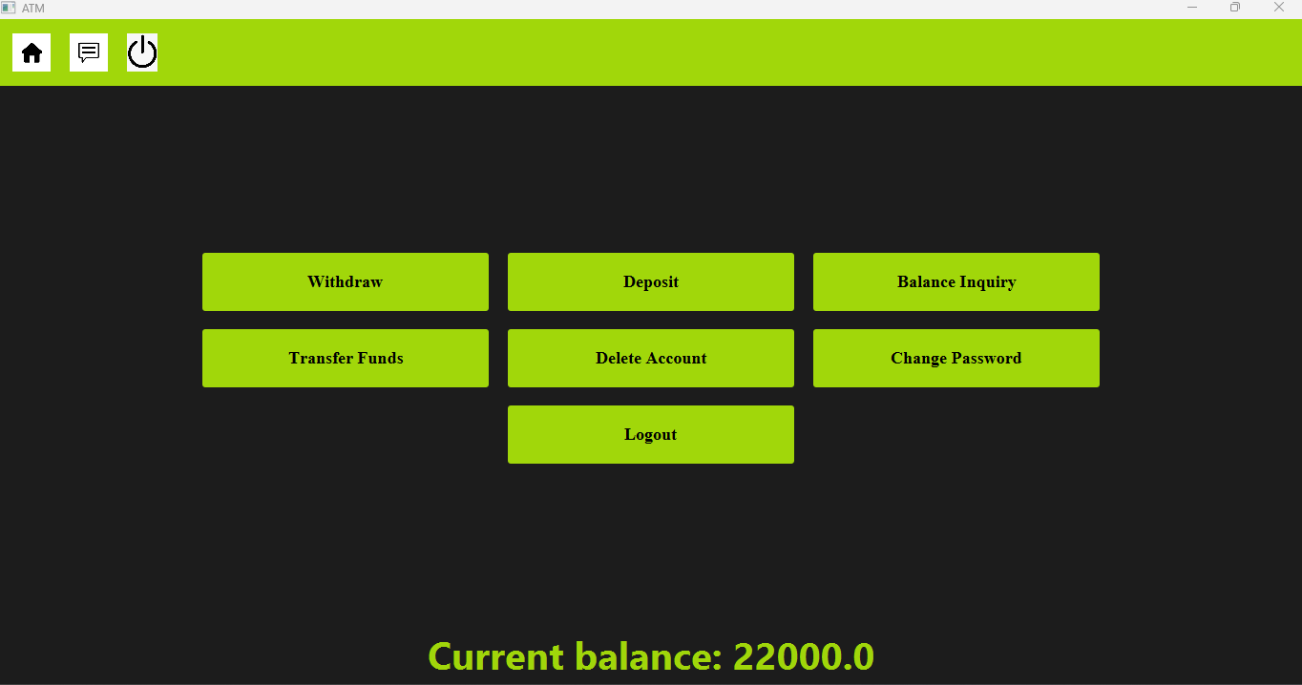

**Account Deletion**

On clicking the Delete button, a new window will appear, which will show a message label that "Are you really want to delete your account" and a warning that "this cannot be undone", and with two buttons, Confirm and Cancel. On clicking the Confirm button, our account will get deleted, and on clicking the Cancel button, our account will not get deleted, and it will direct us to the menu.

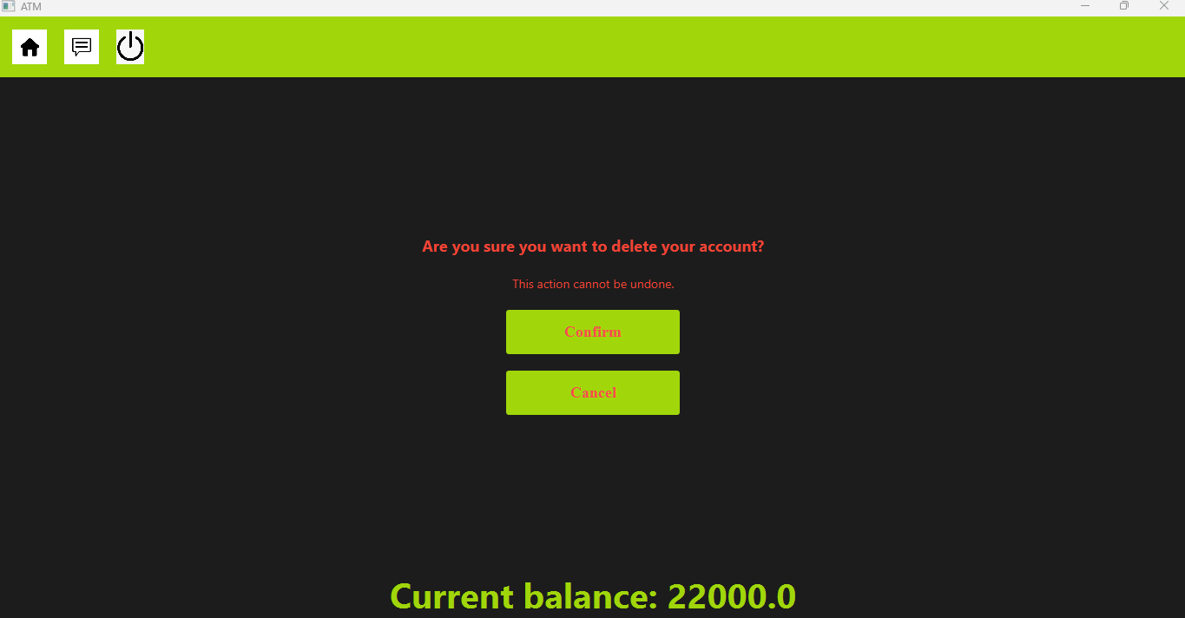

**Change Password**

On clicking the Change Password button, a dialog box will appear which will ask us to enter our current password. And if we enter the correct current password, then it will show another dialog box which asks us to enter the new password. Then we can change our password by this box.

